## **Aim:**

# **Editing and Formatting Axes, Manipulating Data in Tableau data, Pivoting Tableau data.**

## **Solution :**

# **Editing and Formatting Axes:**

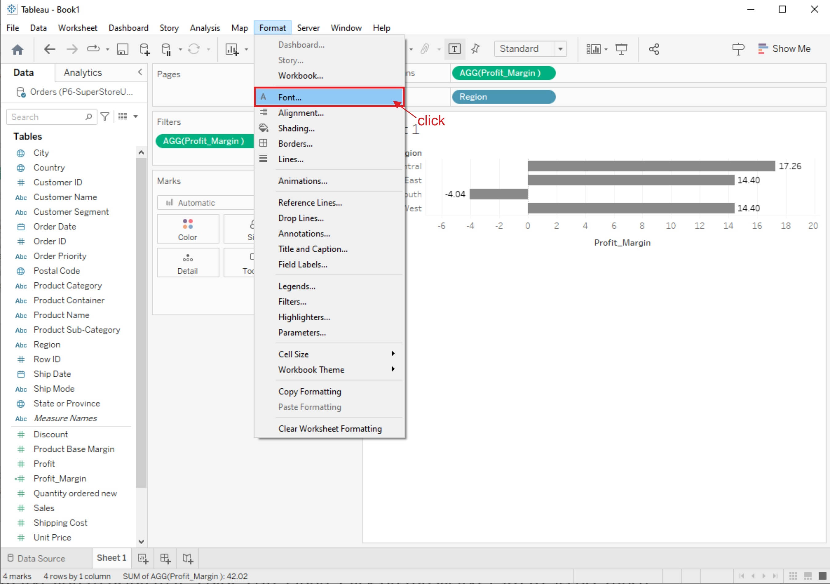

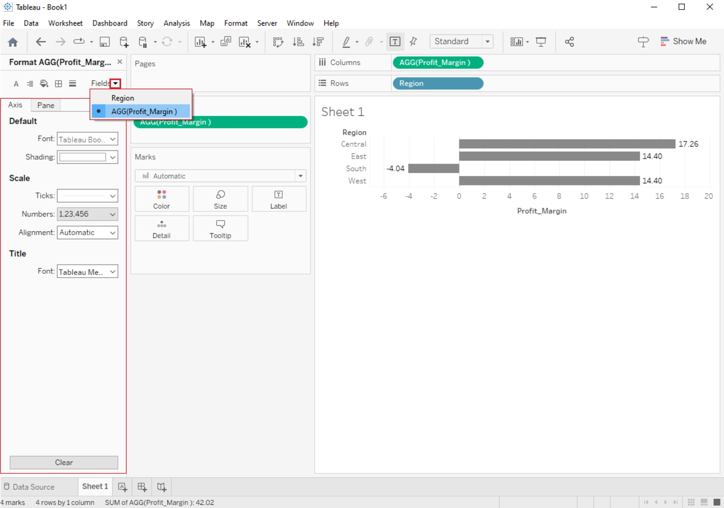

## **1. Edit Axis Title:**

* Click on the axis title you want to edit.
* You can now modify the title text, font, size, color, and alignment using the Format pane or the toolbar at the top.

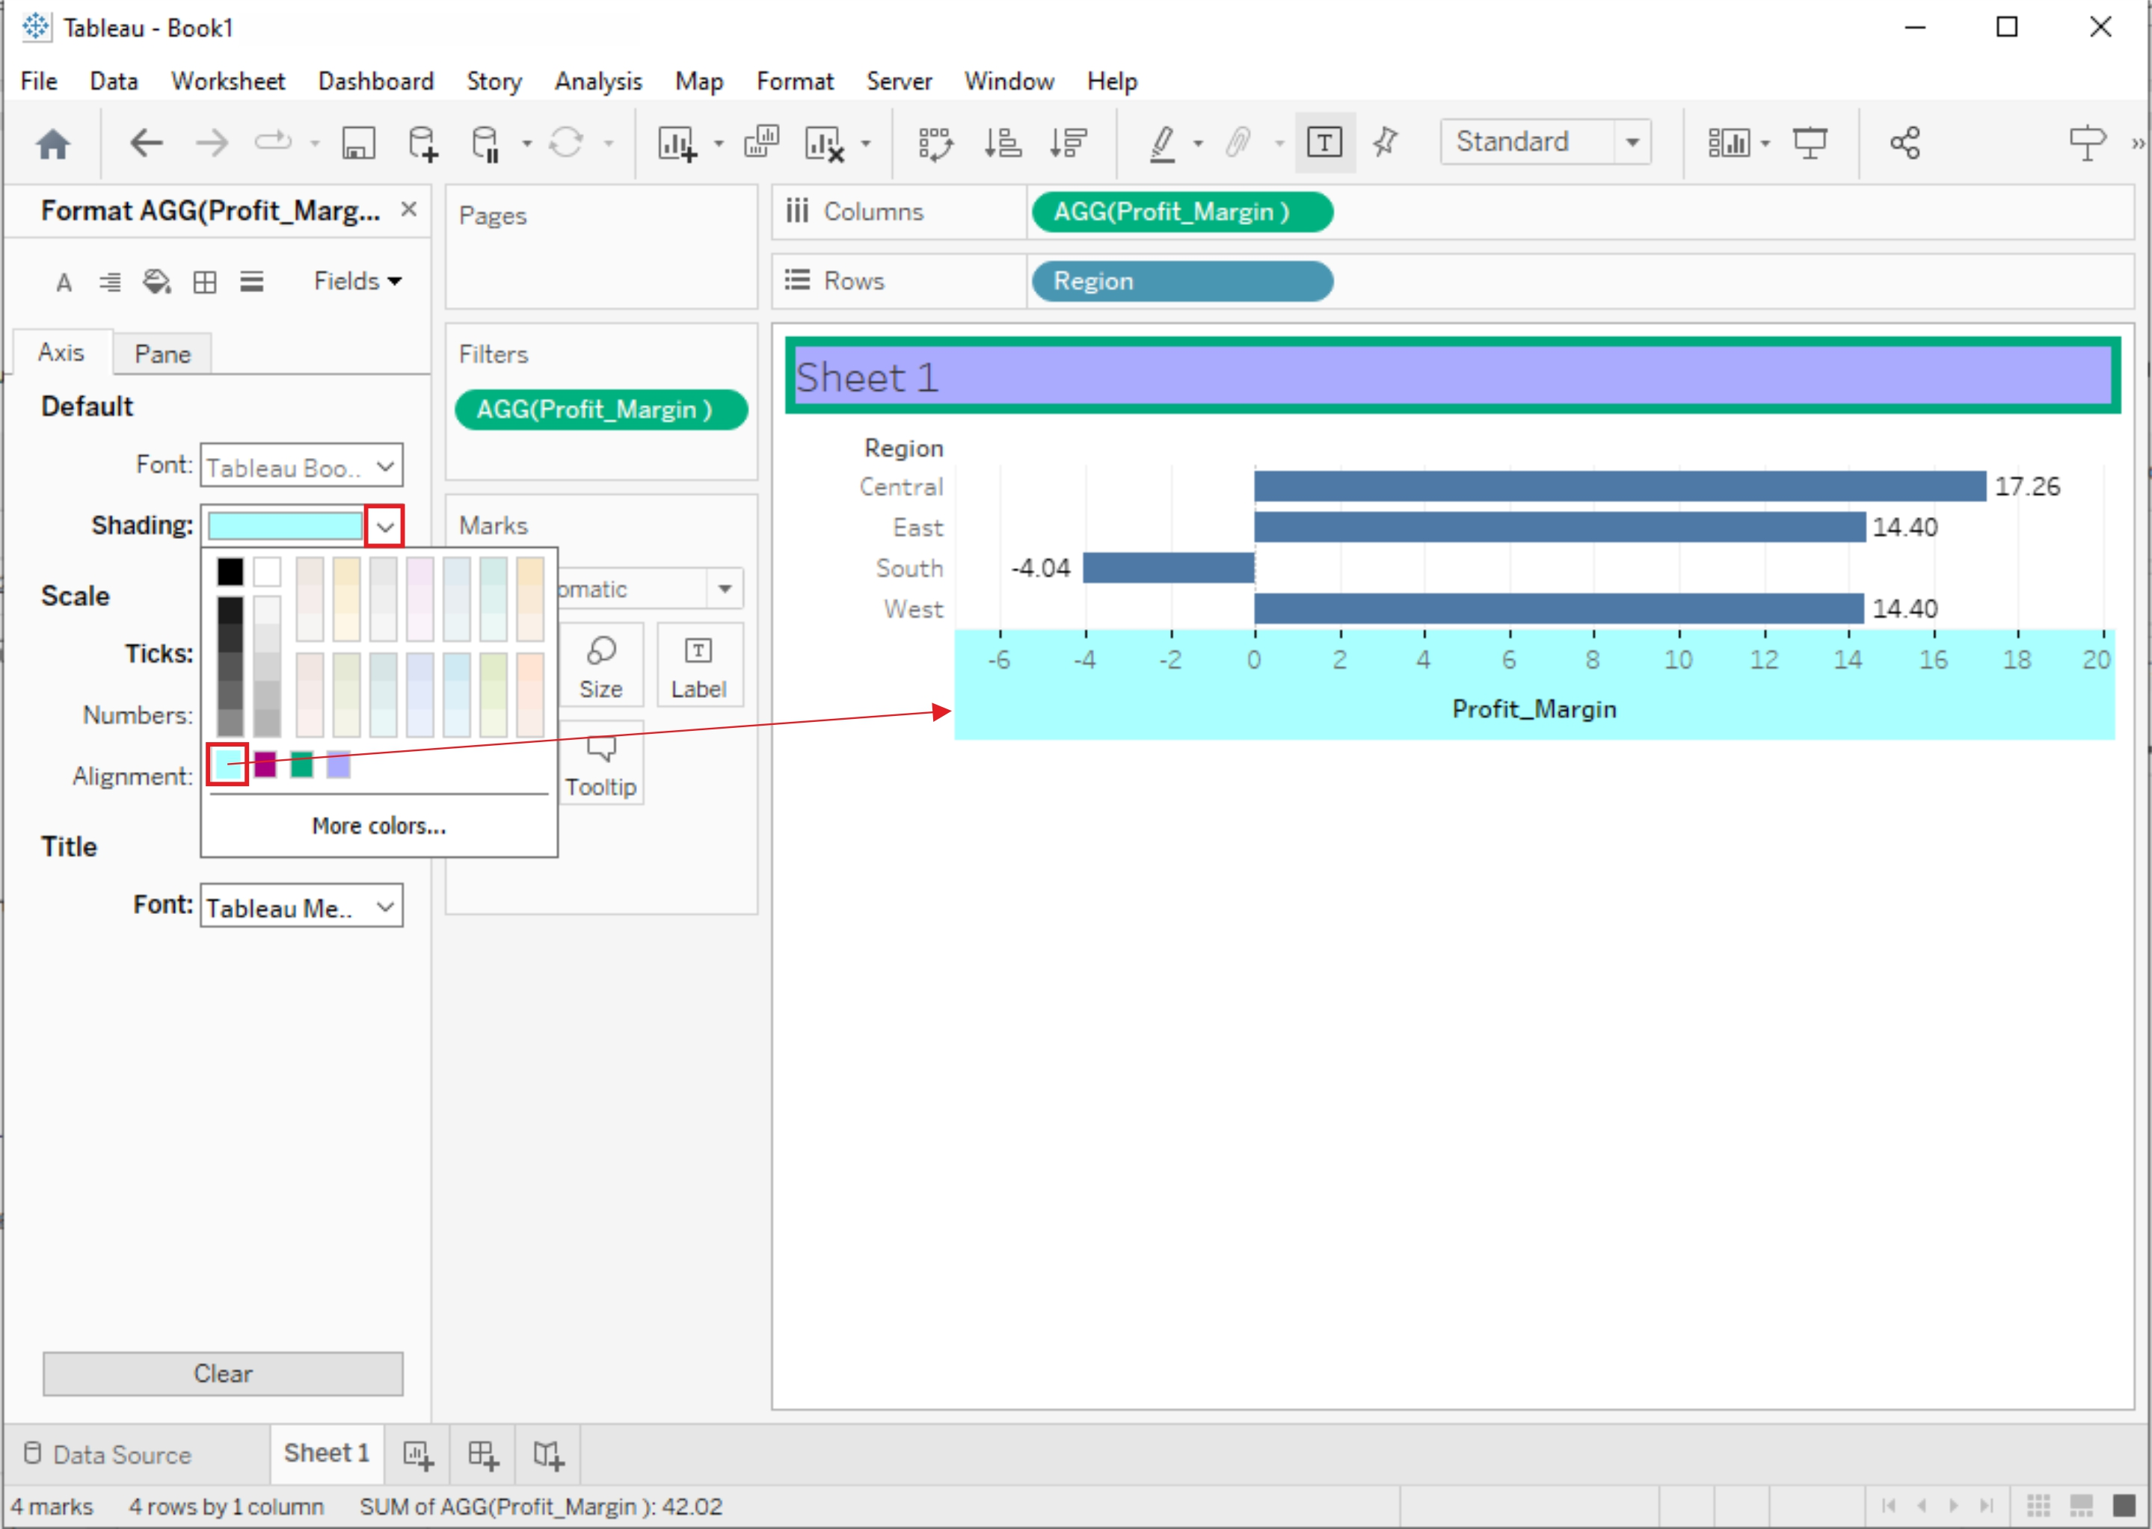

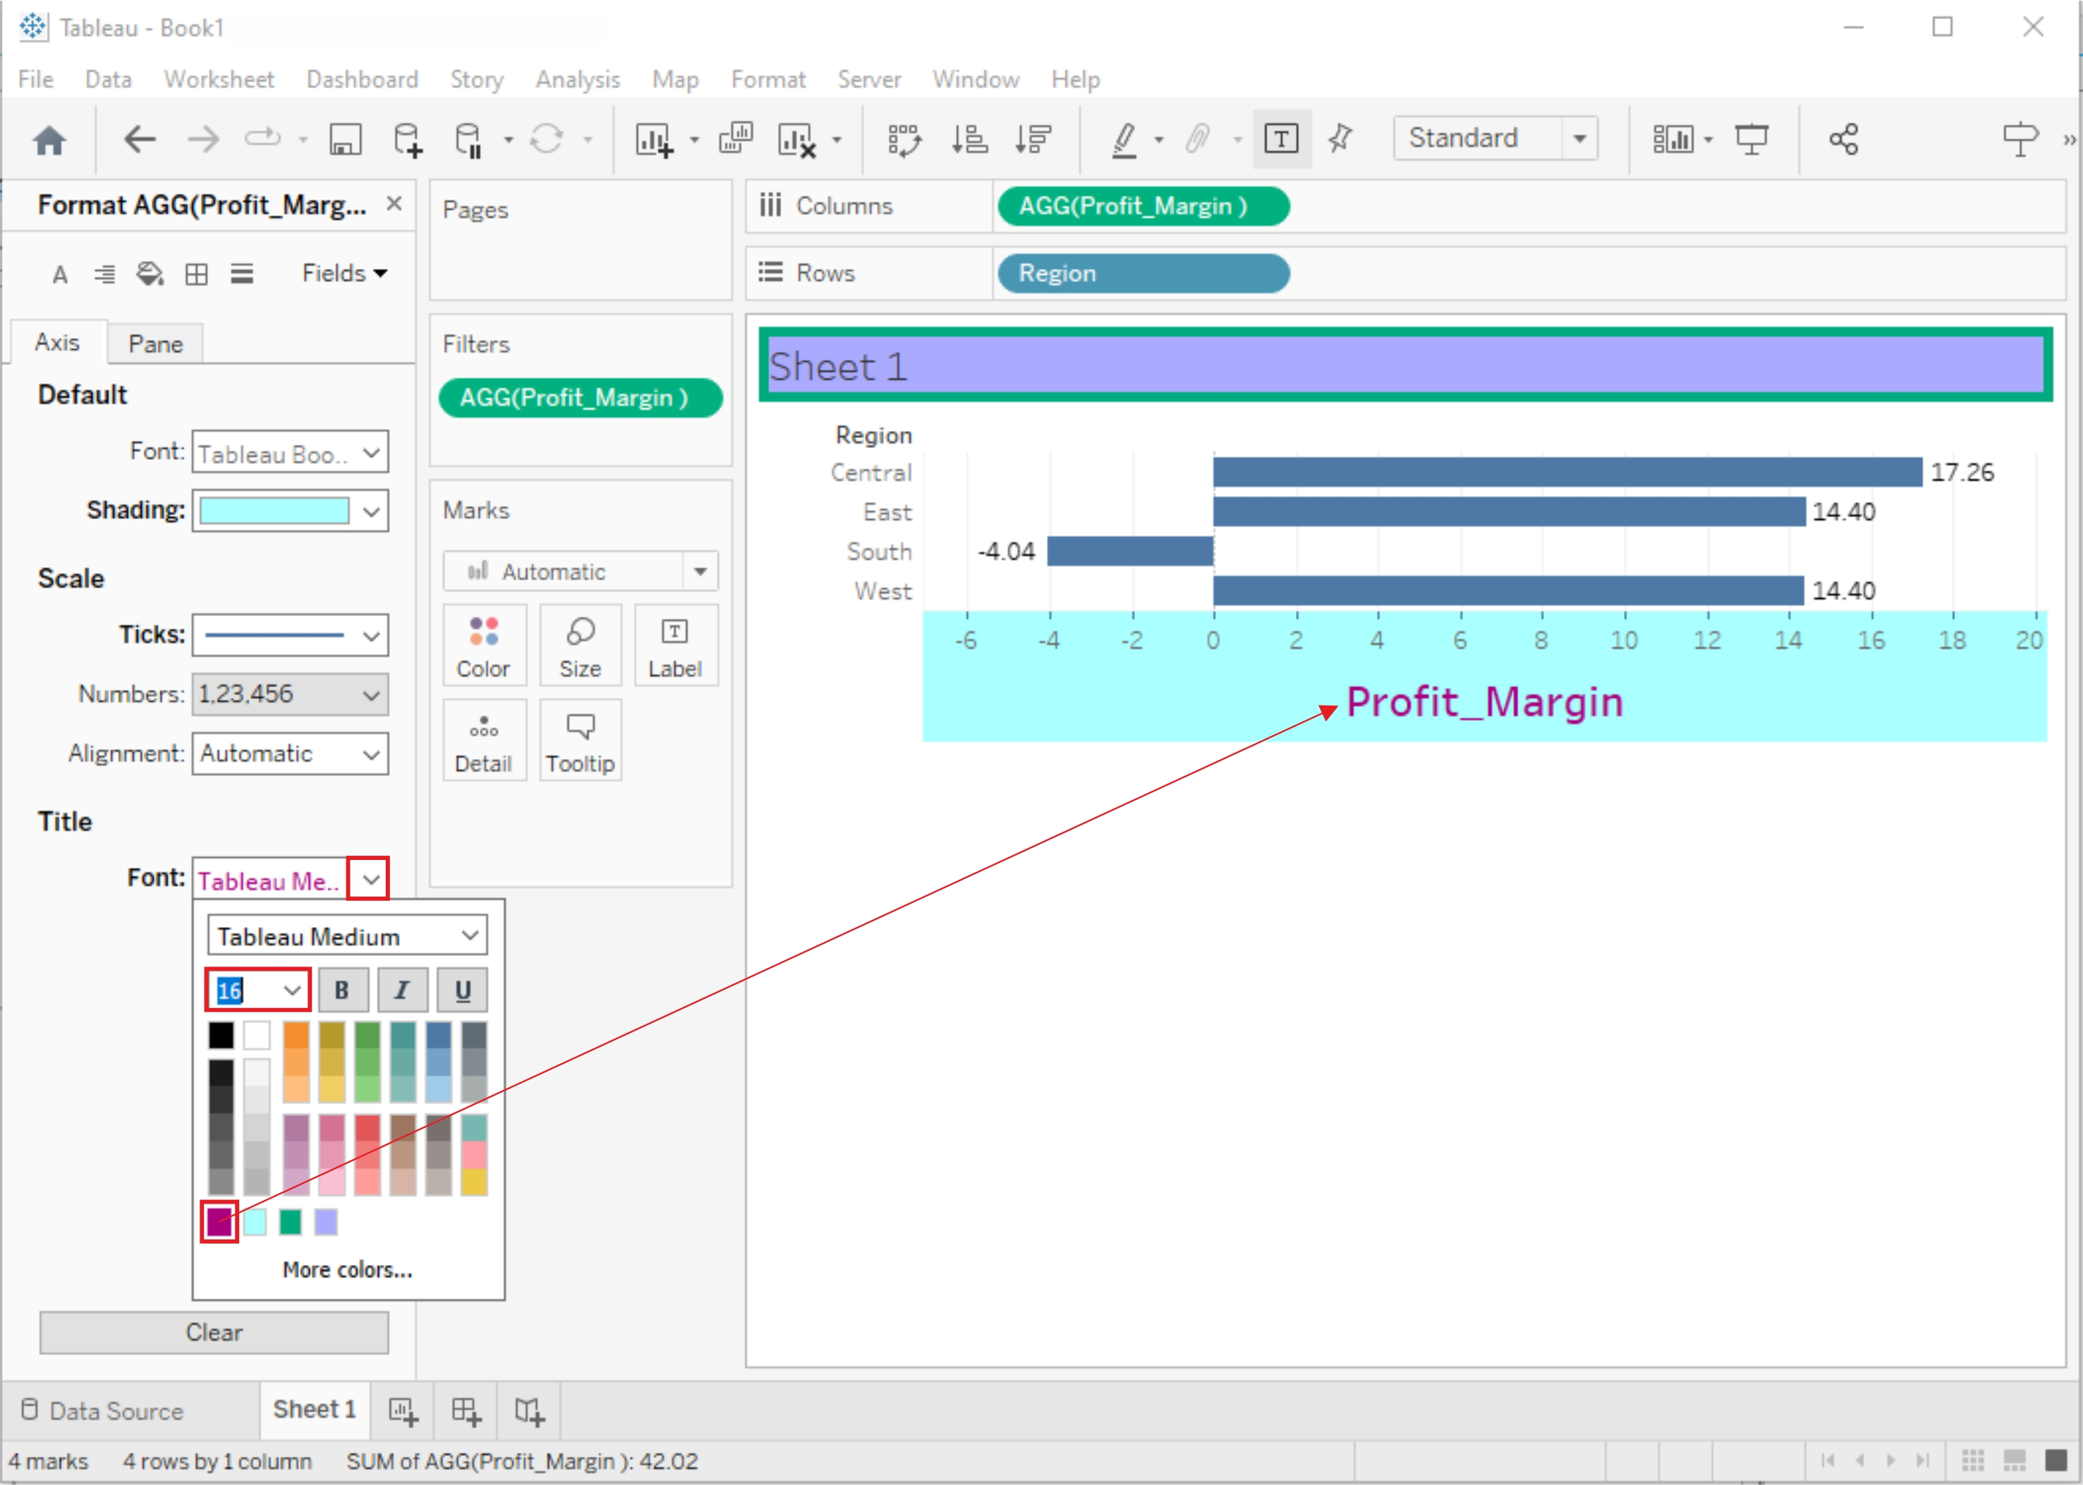

## **2. Edit Axis Labels:**

* Right-click on an axis and select "Edit Axis."
* In the Edit Axis dialog box, you can change the formatting of labels, tick marks, and other axis-related properties.

## **3. Scale and Range:**

* To change the scale or range of an axis, right-click on it and select "Edit Axis."
* In the dialog box, adjust the Minimum and Maximum values, scale, or range according to your needs.

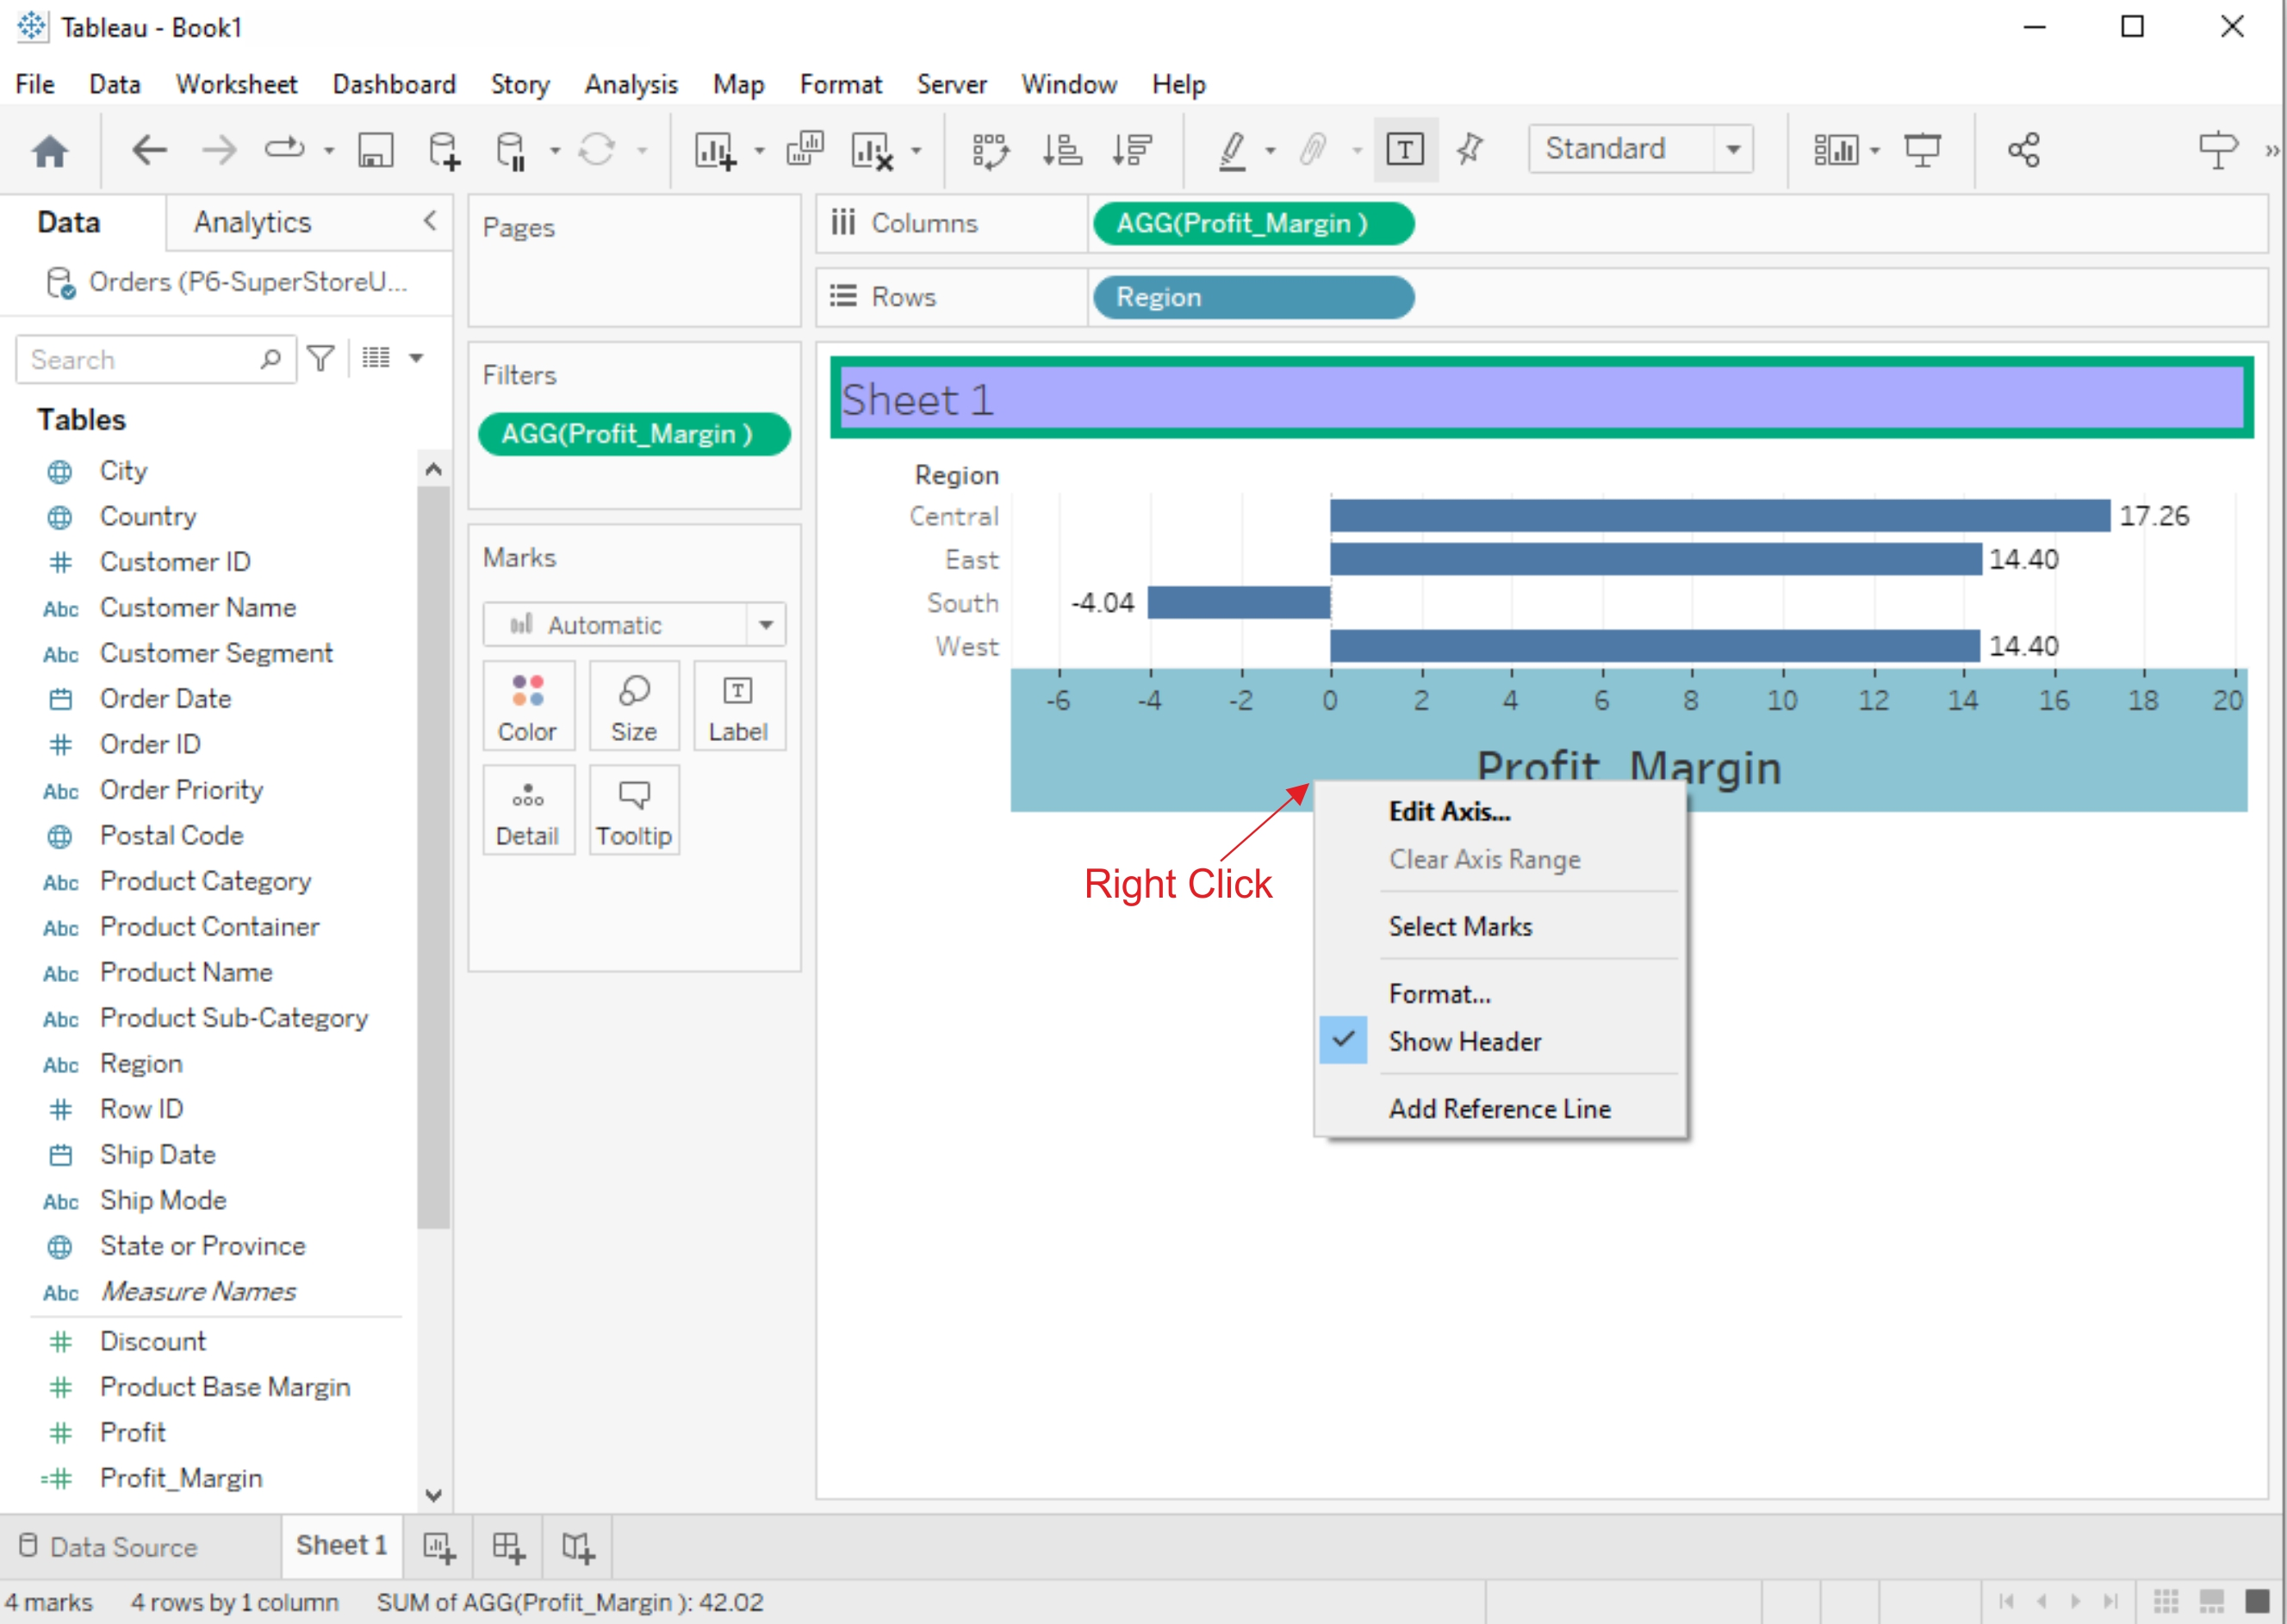

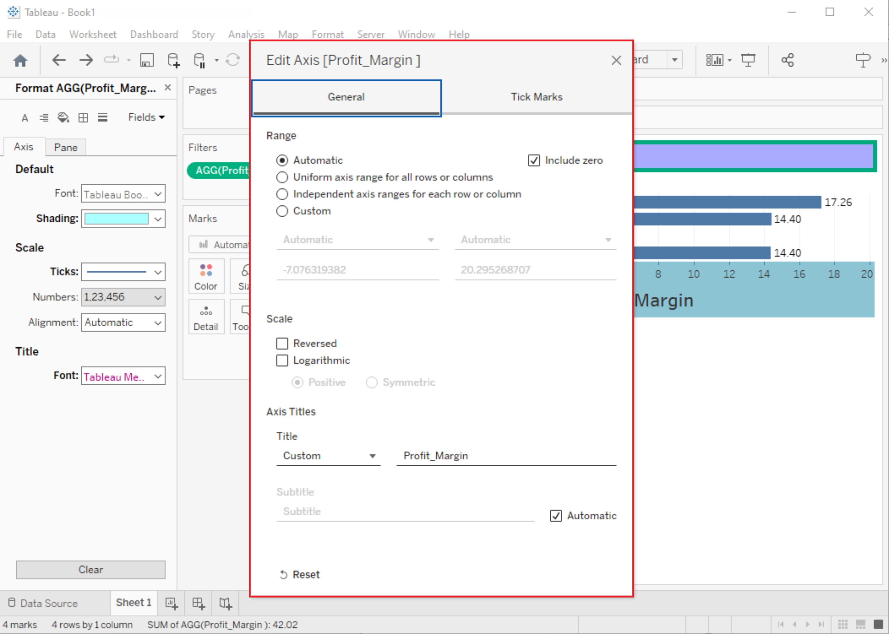

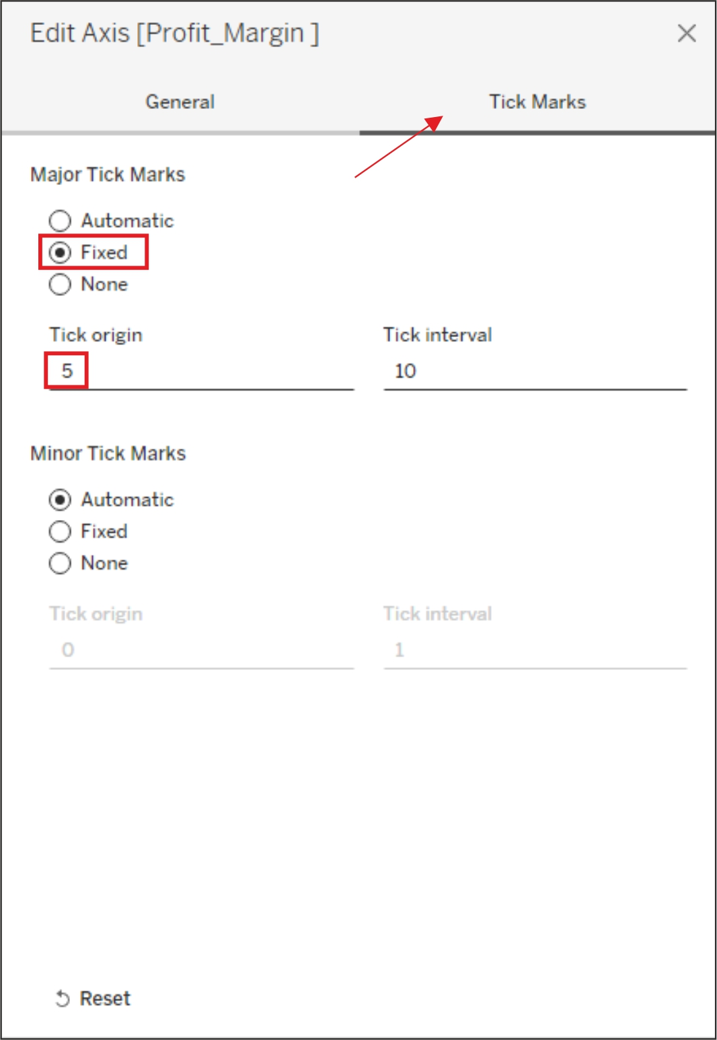

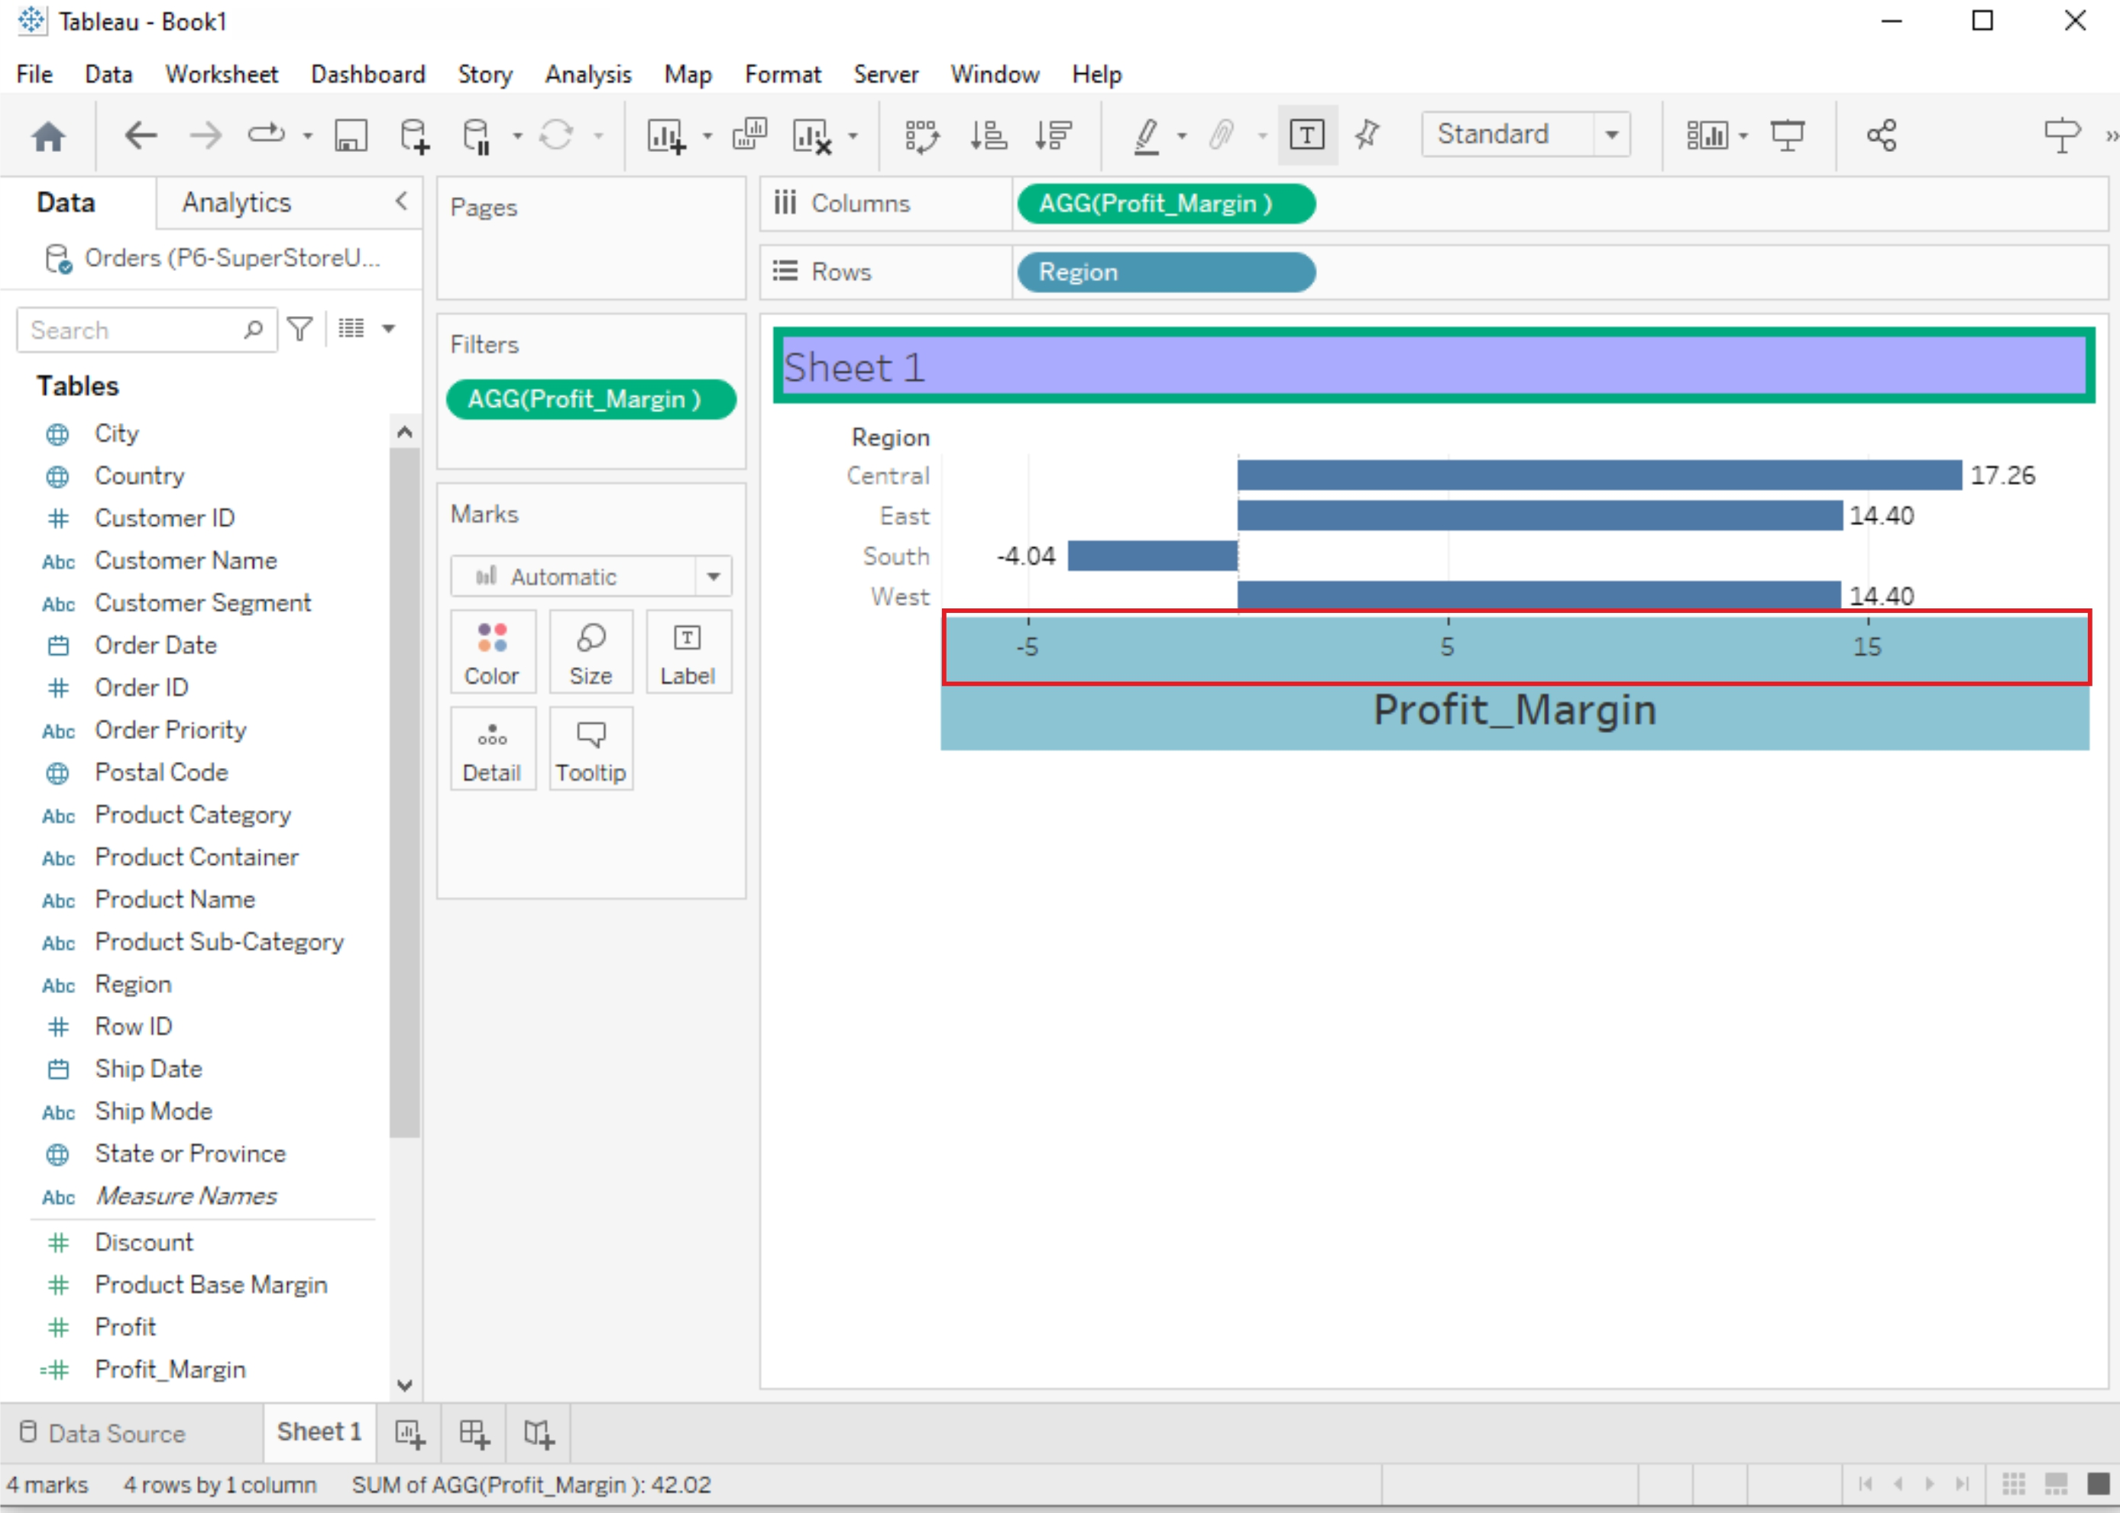

# **Manipulating Data in Tableau data**

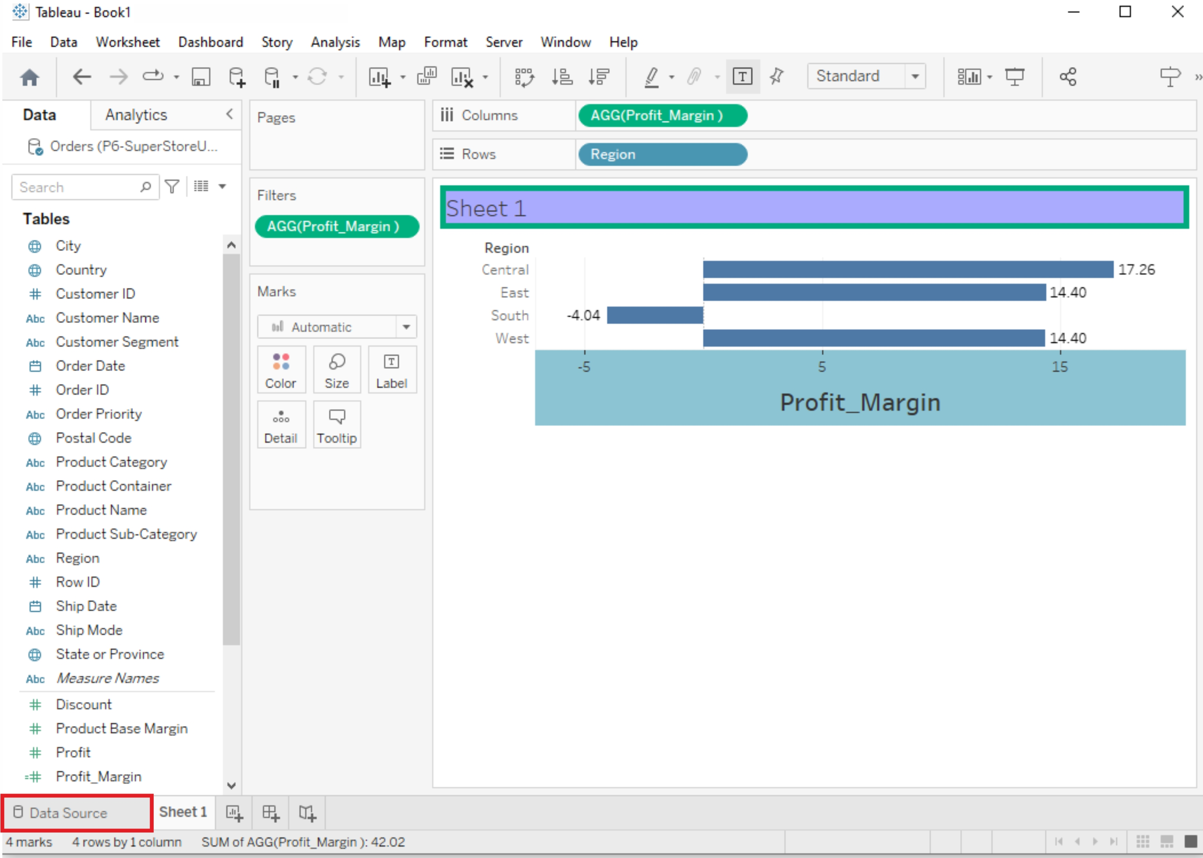

## **Change Data Type**

If Tableau has inferred a wrong data type for a column, the data type can be changed by clicking on the data type symbol in the column header

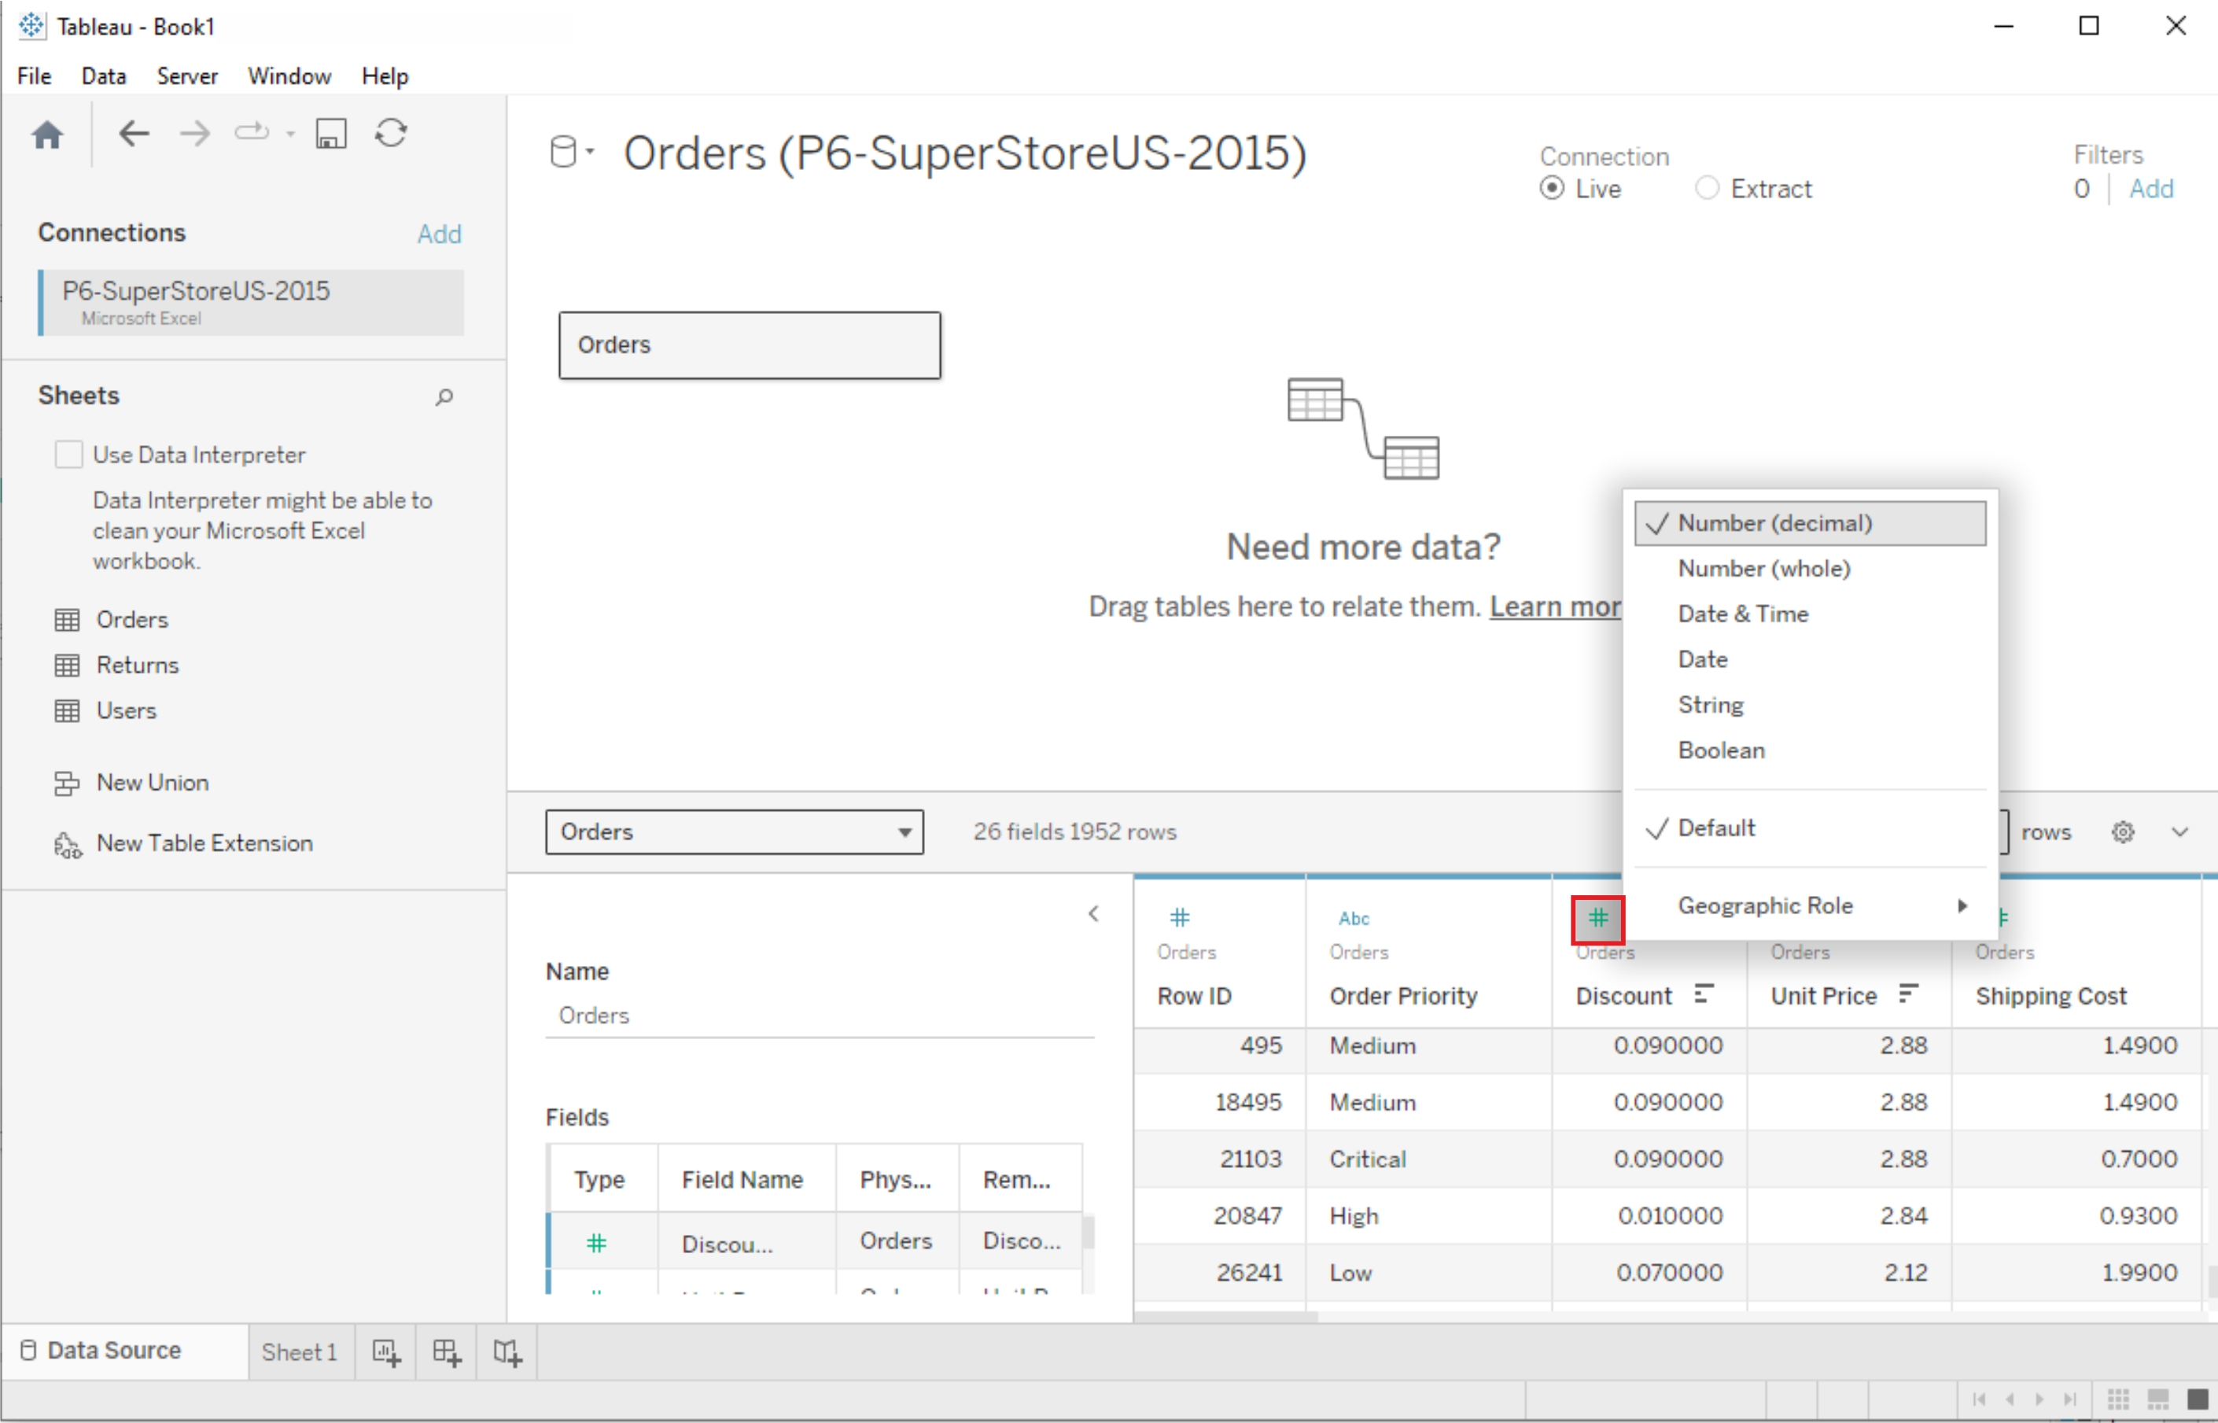

## **New Column(Calculated Fields)**

Calculated fields can be used if you need to create customized logic for manipulating certain data types or data values. There are a large-range of functions available in Tableau that can used individually or collectively for data manipulation

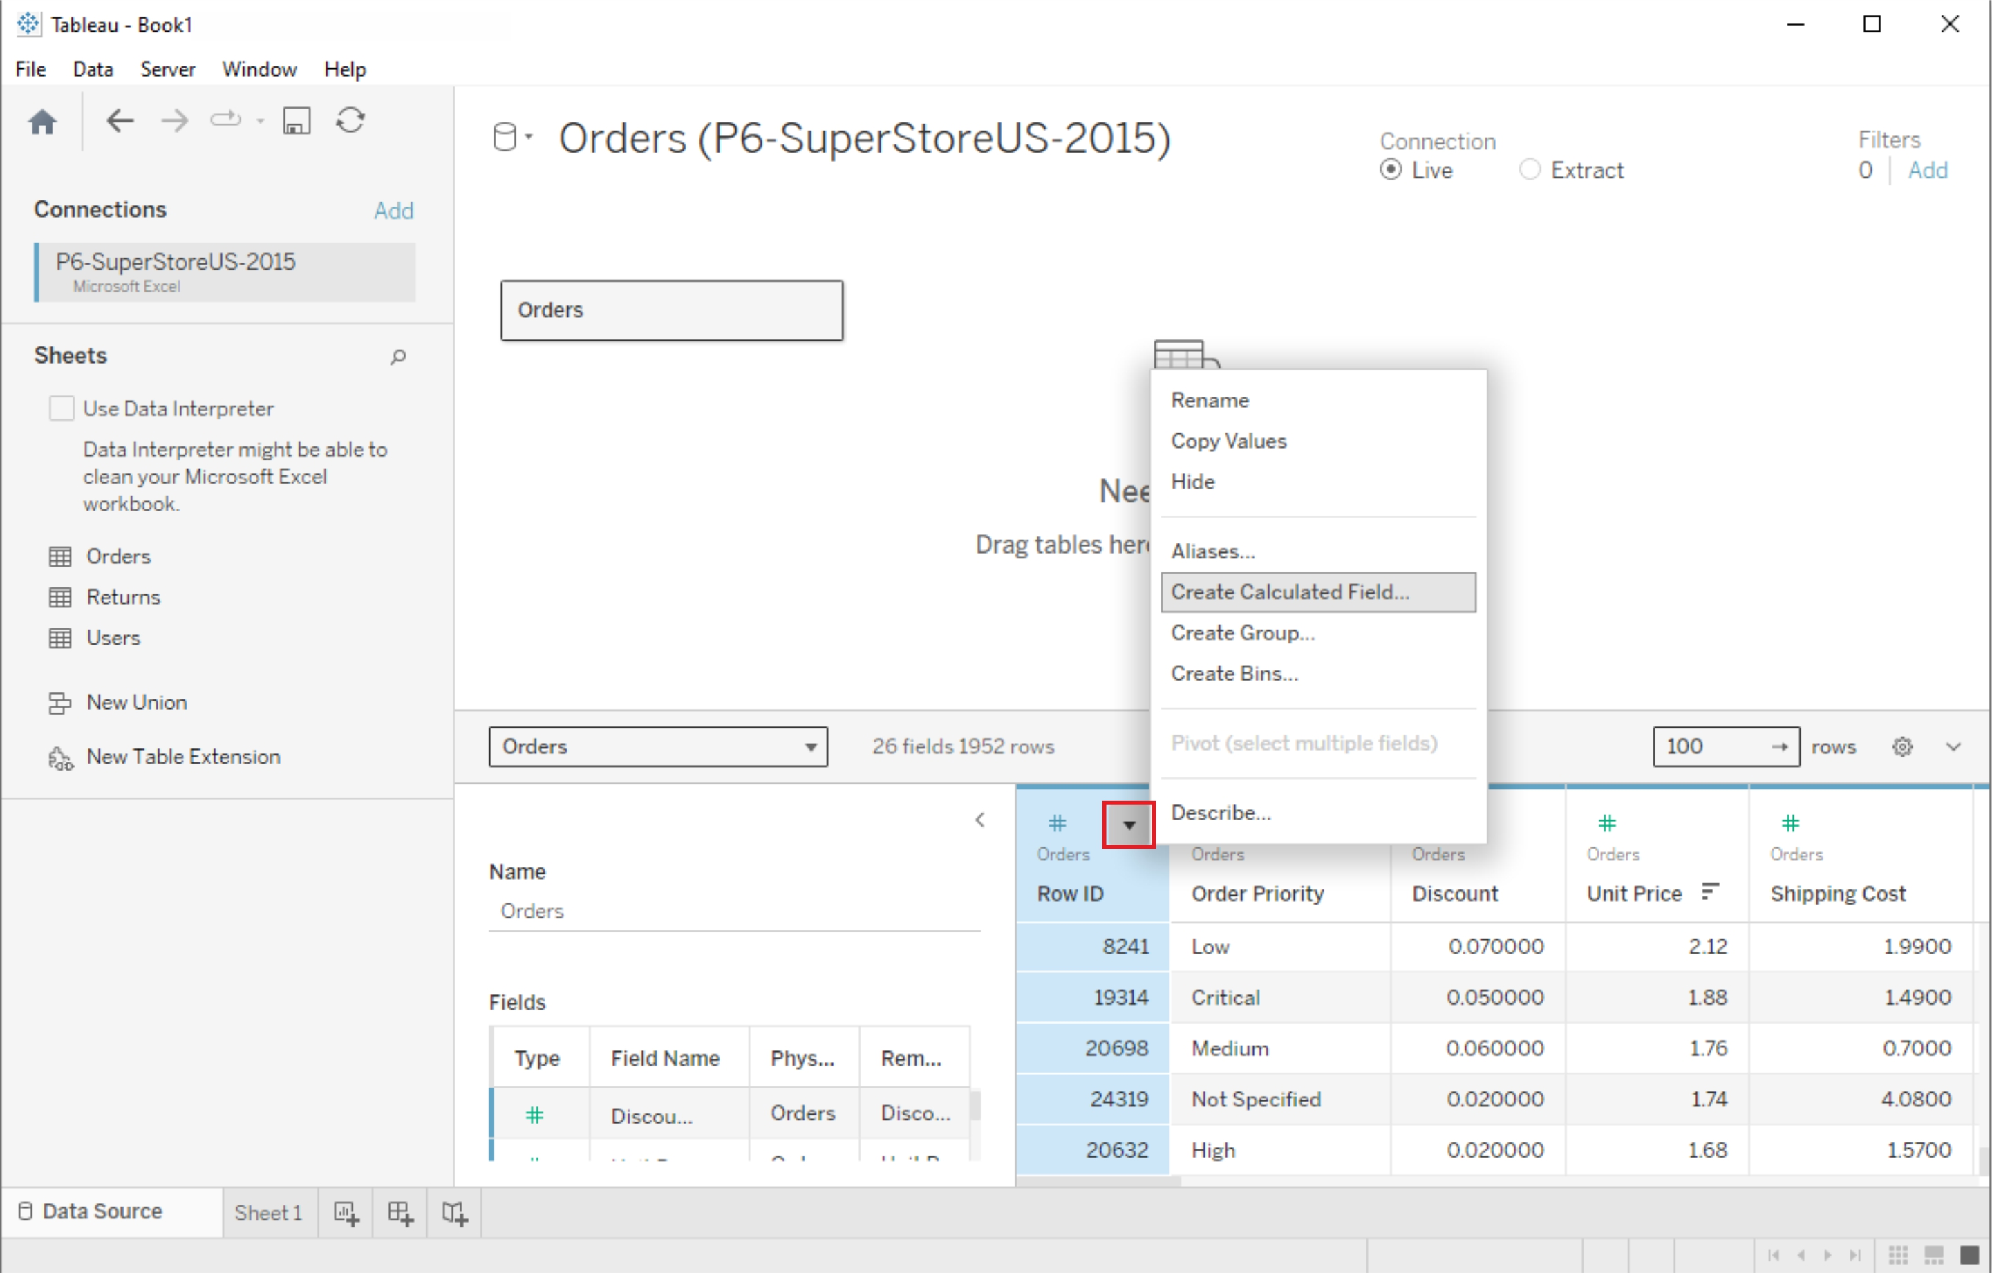

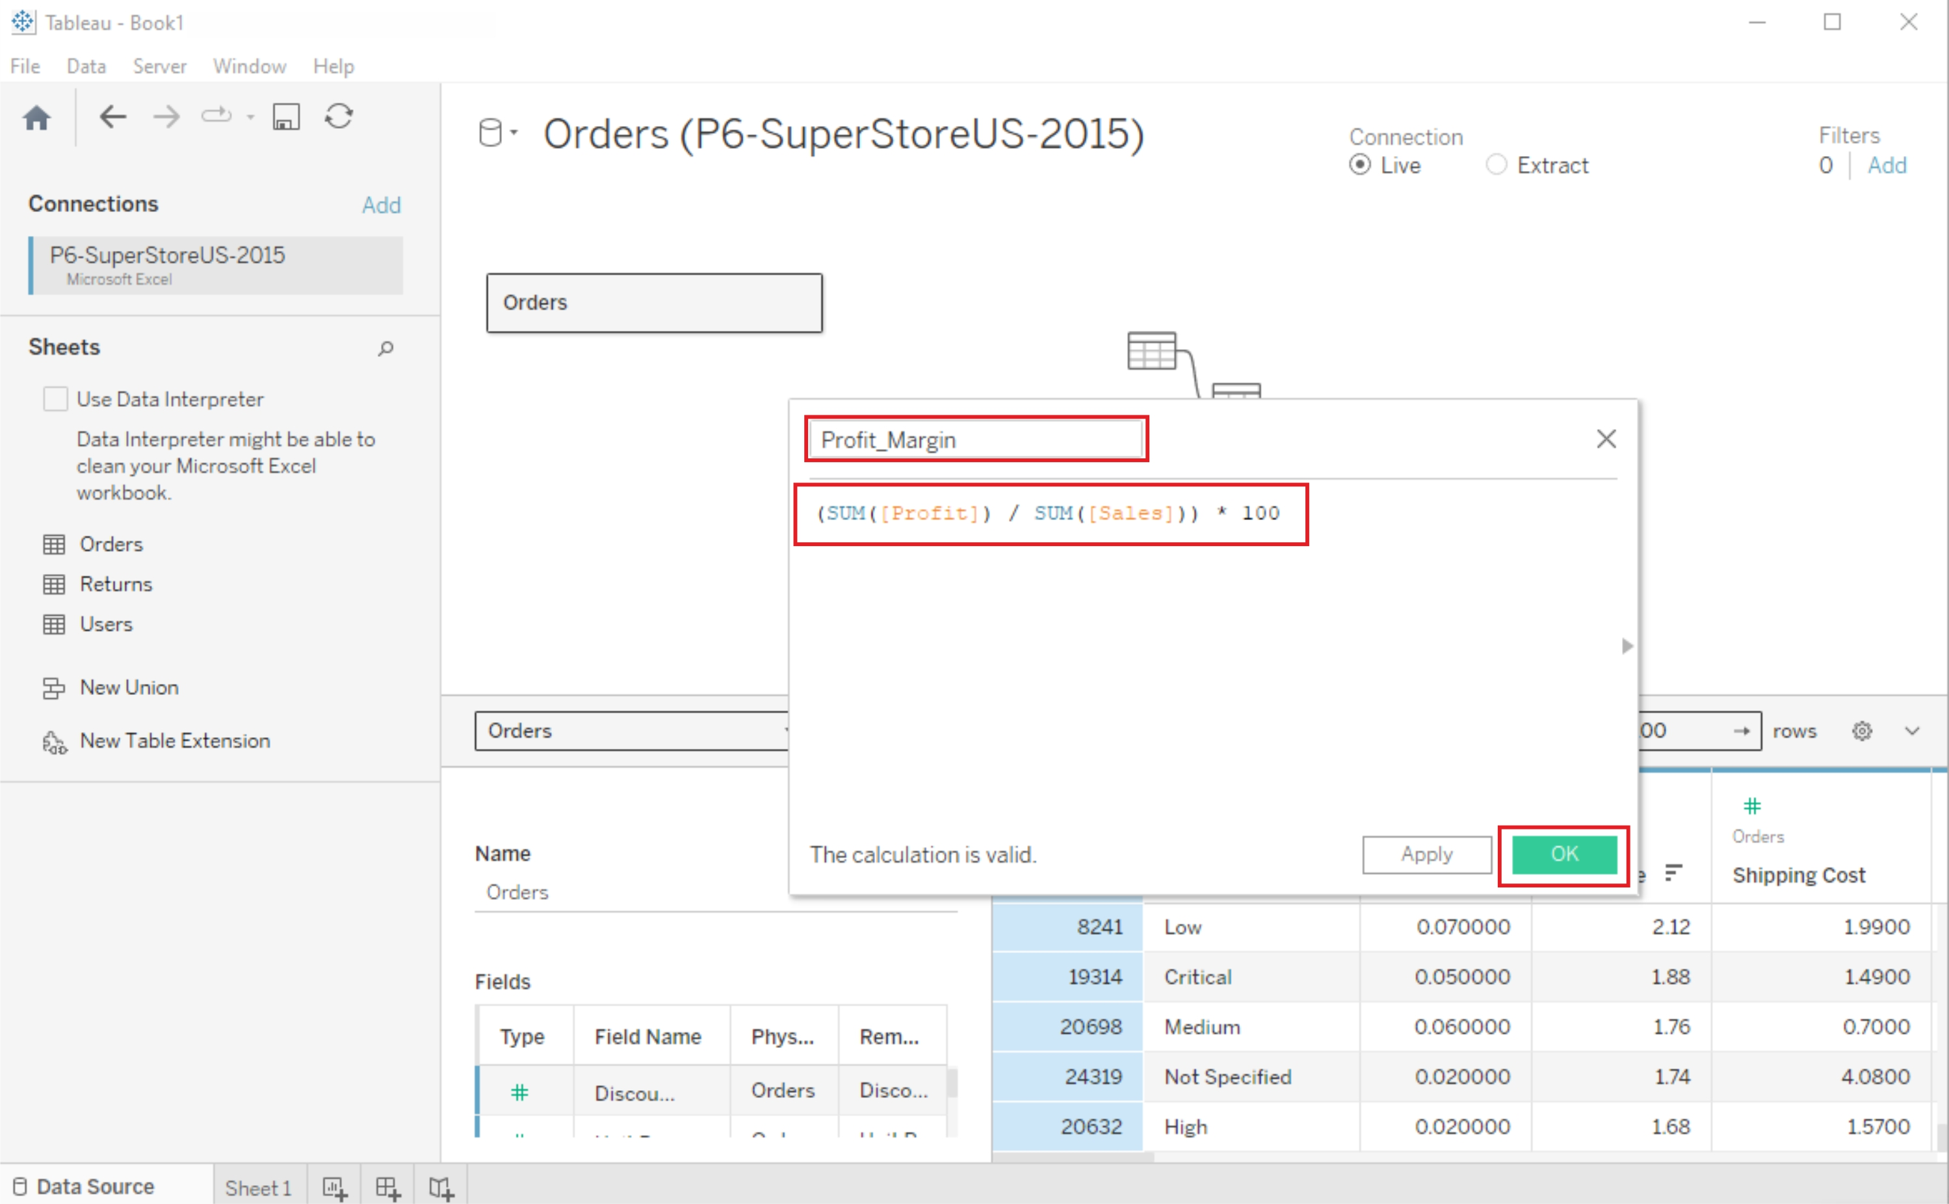

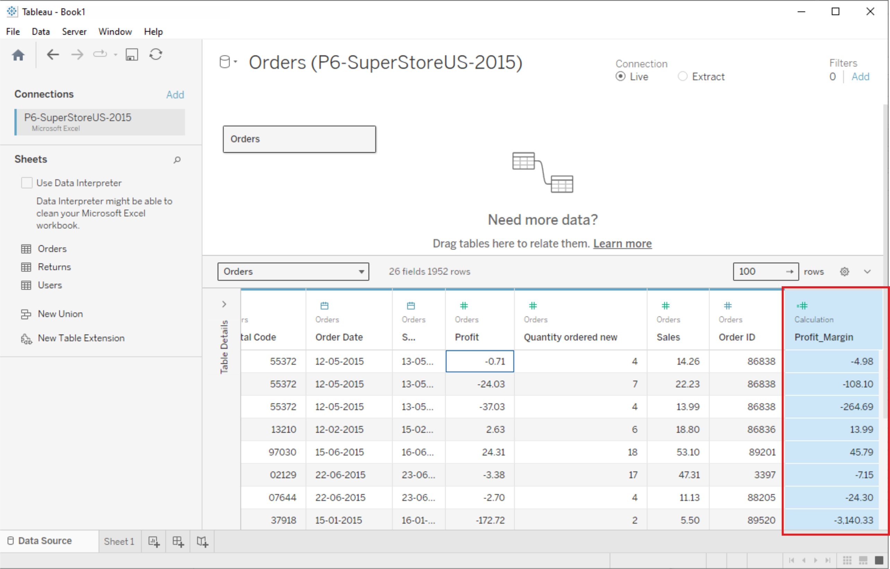

# **Pivoting Tableau data**

Data pivoting enables you to rearrange the columns and rows in a report so you can view data from different perspectives

